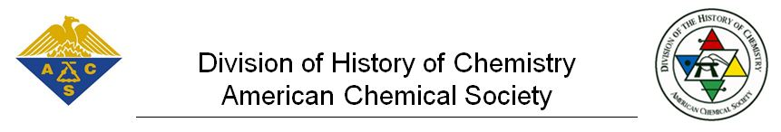

Your name (please print)
Your email address
ACS Member Number
Your proposed caption (35 words maximum) (Please print.)
I agree to the rules of this contest (see below).
Signed and dated:

Contest Rules:
Cartoonist Sidney Harris will draw a cartoon based on the Grand Prize caption. The Grand Prize Winner will receive the original cartoon based on the winning caption. The Runner-up will receive a personally autographed copy of one of Harris’s most famous cartoons chosen by Mr. Harris. Submitters must be members of the American Chemical Society. One submission per ACS member. Names and email addresses for all submitters will be used only by the Division of History of Chemistry (HIST) for this contest’s purposes and all contact information will be deleted from all records at the end of the contest unless you are the Grand Prize Winner, Runner-up or “check the box below” for the free one-year’s membership to HIST. In those cases, your contact information will be retained to fulfill the obligations of the Division of History to Chemistry relative to prizes and the offer of a one-year’s HIST membership. At no time, will any of the submitters’ information be shared with others without your prior permission. The Grand Prize Winner and Runner-up agree to be identified and to report their winning captions for publicity purposes in print and electronic media to include Chemical & Engineering News. Except for the Grand Winner, submitters will retain all copyright ownership rights for all captions submitted. Copyright ownership rights in the Grand Prize Winner’s caption only and the cartoon drawn by Sidney Harris will be transferred to and become the property of Mr. Harris. All entries must be submitted on this official entry form.

Each contestant is eligible to receive a one-year's free membership (July 1, 2019 to June 30, 2020) to the Division of History of Chemistry (new members only) including access to HIST's journal, the Bulletin for the History of Chemistry. If you wish to receive this one-year's free membership (2020), please check the box. The first 100 to respond will receive a hardcopy of the journal. All will have electronic access to the journal. Please include your mailing address here:

Submissions must be received at ACSHISTcartoon@yahoo.com no later than April 1, 2019.

ACS and the ACS Division of History of Chemistry takes your privacy seriously. Please see ACS’s Privacy Statement www.acs.org/content/acs/en/privacy.html relative to the processing of any personal information.

